**Part 1**

1. -bash: simple.sh: command not found
2. -bash: ./simple.sh: Permission denied

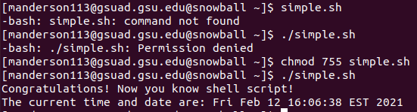

1. prevents echo from outputting the default trailing newline, so the date will be displayed on the same line instead of the next
2. yes it is a comment, only on the first line does # function as something other than a comment, usually to define the shell to be used
3. no it is not a comment, it is clarifying that this is a bash script using the bash shell

**Part 2**

1. Six



1. No errors, now that the directory that simple.sh is in the PATH, it will first check that directory for it before declaring it ‘not found’.
2. No
3. It’s the same errors as before, because the PATH variable changes are not saved.

**Part 3**

**Line Numbers**

1. remove $, must start with #
2. change from
   1. /* comment */
   2. to
   3. # comment
3. changed END to ENDHERE, see line 13
4. removed the dash to match the ending text ENDHERE in line 7
5. removed the ls, added @student.gsu.edu to the email address
   1. from
   2. ls mail $1 < Result
   3. to
   4. mail $1@student.gsu.edu < Result

The script successfully emailed me the following with no subject:

The regex [^a]*ce can match the string(s):

piece